www.ccea.org.uk
Information for Students and Parents
8
February,
2022

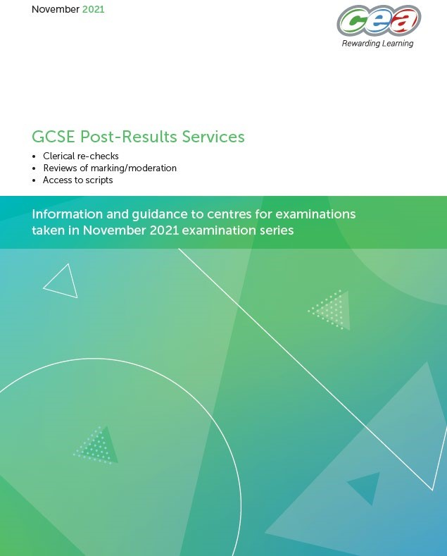
Post Results Services
- CCEA Post Results booklet, November 2021, is now available on CCEA’s website:
CCEA Post Results Services November 2021
CCEA Post Results Services November 2021 – Summary document
- CCEA Results Helpline available from 9 February for Centres and 10 February for candidates / parents
Telephone - 02890261220, email - helpline@ccea.org.

Summer 2022 Assessment Arrangements
Reminder
- Omissions
  - Students permitted to omit one unit of assessment from the vast majority of GCSE and GCE qualifications
  - Reduction in the coursework requirements
  - A number of assessments adapted to align with public health guidance
- Grading
  - “…ensure that outcomes in 2022 are higher than those of pre pandemic years….”
  - “…examiner judgement is at the centre of the awarding process and takes account of the significant disruption that young people have encountered.”

Summer 2022 Reserve Series
- Limited to mandatory A2 units plus 5 GCSEs
- 68 assessments in total
- Series to run from 20 June – 5 July 2022

- Results issued early Autumn
- Further information will be provided in the coming weeks

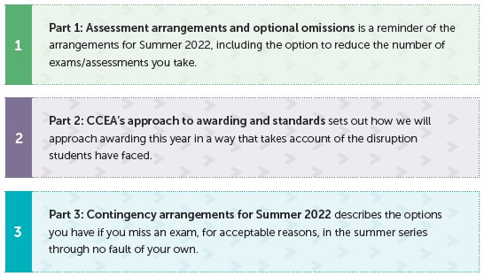
Student and Parent Guidance

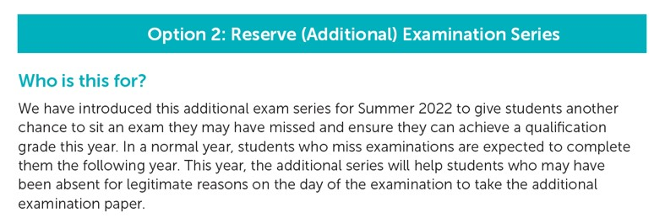

Student Information and Support
Summer 2022 support materials available
Student and Parent guide: 2021/22 awarding arrangements  2022 Grading Pathways video  Preparing for exams – student guide  Summer 2022 Web Area  Dedicated Student Area  Short video on ‘How grades will be awarded in 2021/22’ (British and Irish sign language)  Regularly updated Frequently Asked Questions (FAQs)  Case study on ‘Examples of Grading and Achieving the Higher Grade from Two Pathways’  Mental Health and Wellbeing Section  ‘Key Year Facts for 2021/22’ web text  Students and Parents section on main homepage | 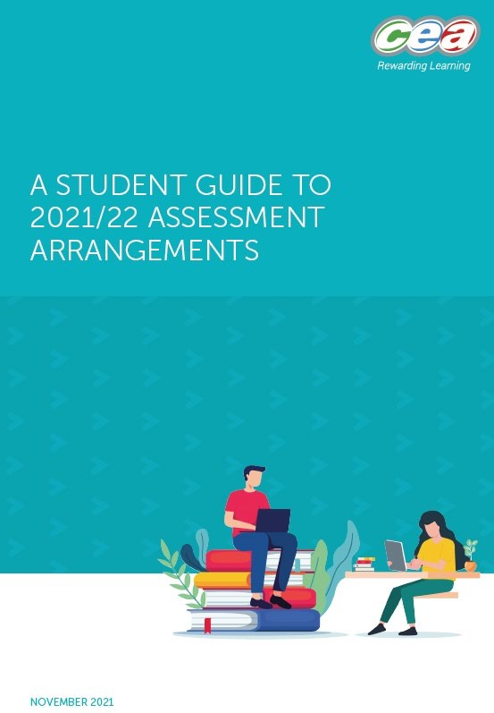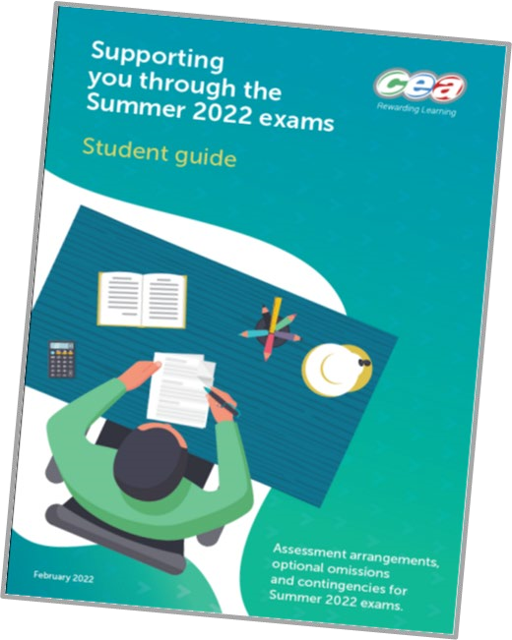
ccea.org.uk/summer-2022/student-area
Support Materials & Communications - February 2022

