ACCELERATED READER YEAR 8
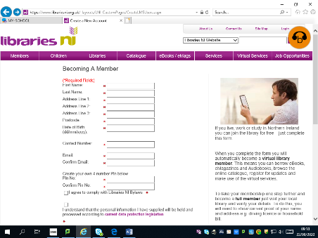
- Sign up to Libraries NI app- this is a free site and you will need your parent/guardian to also complete the form. Please go to https://www.librariesni.org.uk/Pages/LNIeBooksandeMagazines.aspx
Click Get a Membership Number.

2) You can also download the app on GOOGLE Play or the APP Store (iPhone). This will be very useful as you will have access to your own account in school as well as at home.
From books and magazines to local history resources, Libraries NI has a host of fabulous services and exciting events that will lead you on a journey of discovery.

You can join the library​ at any age and membership is free. It is free to borrow books, eMagazines and use computers. Some charges apply for other items and services such as requests for books - view charges information. (Available to read at Libraries NI)
With 98 public libraries and mobile stops across Northern Ireland you will be sure to find one near you.
You can use your library card at any public library in Northern Ireland. This means you can borrow items from one library and return them to another.

