Submitting work on TEAMs’ Assignments

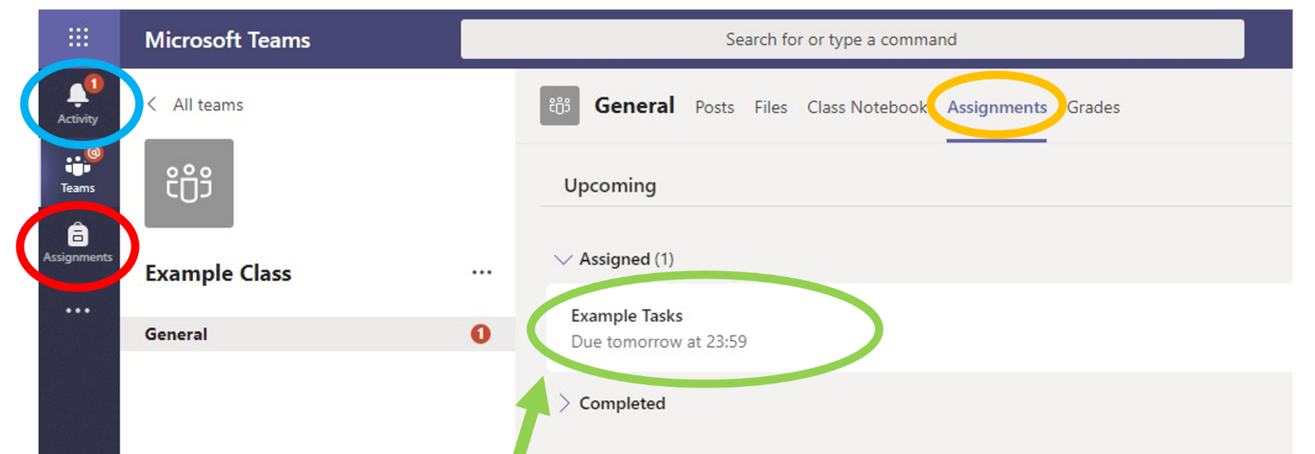
Three ways to access TEAMs’ Assignments.
- Notification - Received every time your teacher sets a new assignment for you, which is circled in blue. Notifications will also appear in the Teams’ General Channel ‘Posts’ - Click it to be brought to the assignment.
- Click the ’Assignments Button’ in the left-hand menu to see all the different assignments set by your teacher,
- You can click into your class and click on the ‘Assignments Tab’ circled in yellow.
Click on the assignment to access the task.
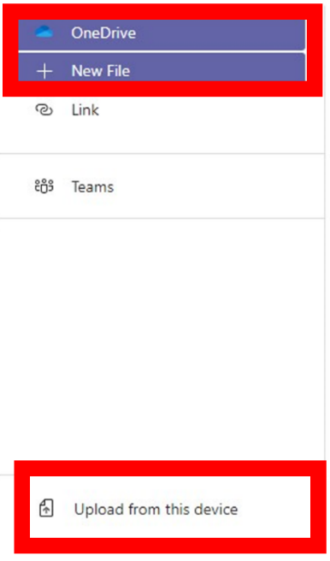
Adding Your Own Work
To add work (your own documents or pictures of handwritten work), you can either upload /attach a document or picture
1. You can most typically ‘Attach’ your document from:
Your ‘OneDrive’
Choose ‘Upload from your device’ – a document or a picture of work
Attaching a picture or document can only be viewed by your teacher once you ‘Hand in’

2. Or you may first need to create a new document, then complete your work in it.
Click ‘+ New File’
You will now have created your document under ‘Student Work’
To start your work, click on the document name.
Turn in Assignments
To turn in an assignment, select its assignment card. Depending on the status of your assignment, you may be turning your work in on time, late, or submitting revised work.
Navigate to the General channel in the desired classroom, then select Assignments.
Your upcoming assignments will show in order of when they're due. Select any assignment card to open it and view the assignment’s details.

If your teacher specified a document for you to turn in, click to open that and it should autosave for you as you work on it OR
You may have other files to attach to this assignment, so select +Add work and upload your file (office document/picture of work etc).
Note: You can attach a file up to 50 mb in size.
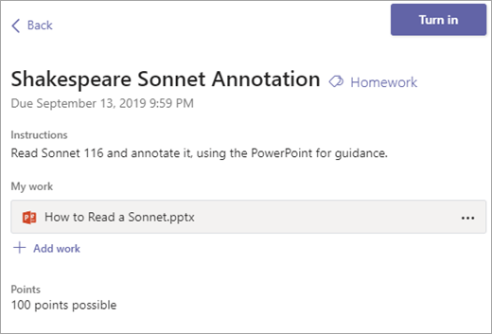

Select the Turn in button to turn in an assignment. The button will change depending on the status:
Turn in again if you’re editing an assignment you’ve already turned in and need to submit work again.
Turn in late if you’re turning in your assignment after the due date, but your teacher has allowed late turn-ins or asked for a revision.
Not turned in if the assignment is past due and your teacher is no longer accepting turn-ins. You cannot turn in work.
Undo turn in if you decide you want to edit your assignment before the due date. You'll need to turn it in again after you make your edits.

Uploading a TEAMs’ Assignment on a Mobile/Personal Device
If you are uploading a document, follow the guide above as uploading a document from a phone or tablet is the same process. However, if you have piece of written work that you need to upload, you can use your tablet or phone to take a picture of your work.
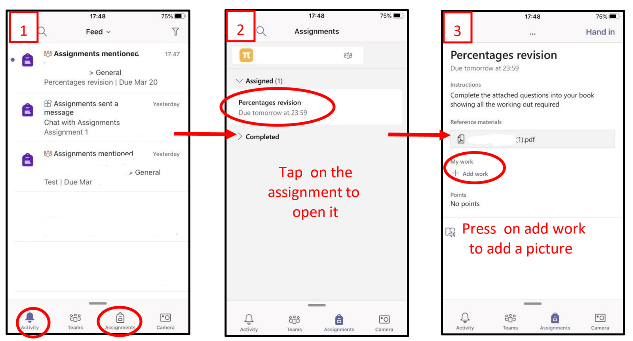

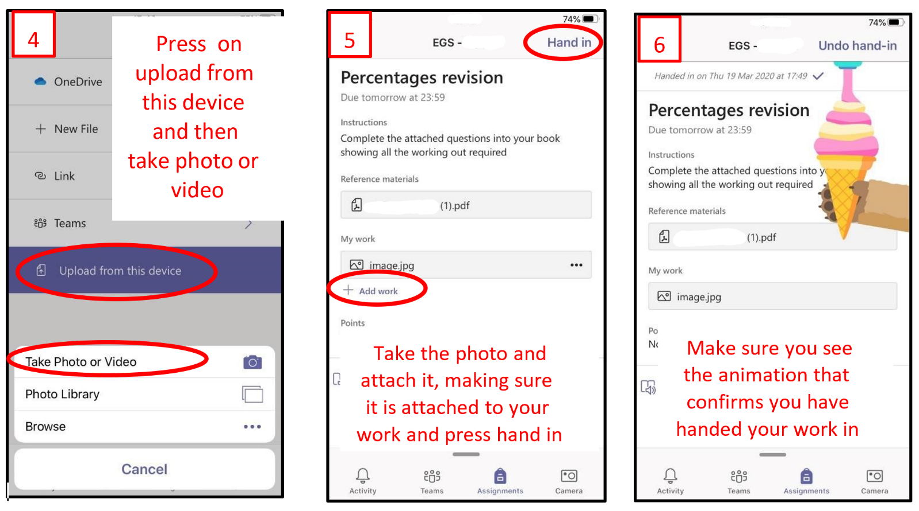

TEAMs – Getting feedback and responding to feedback
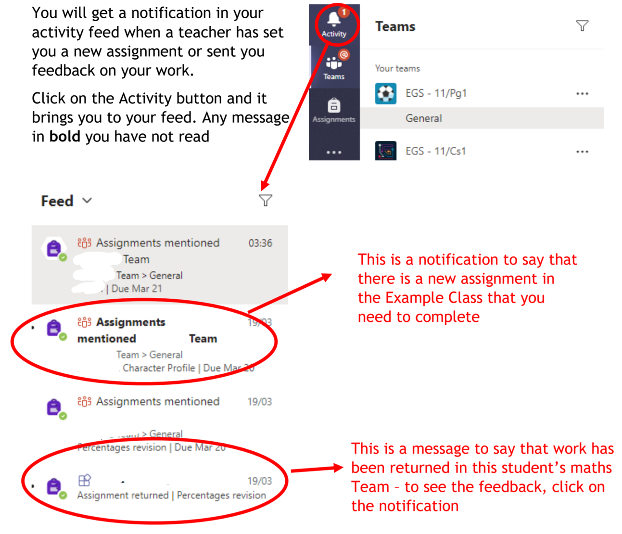
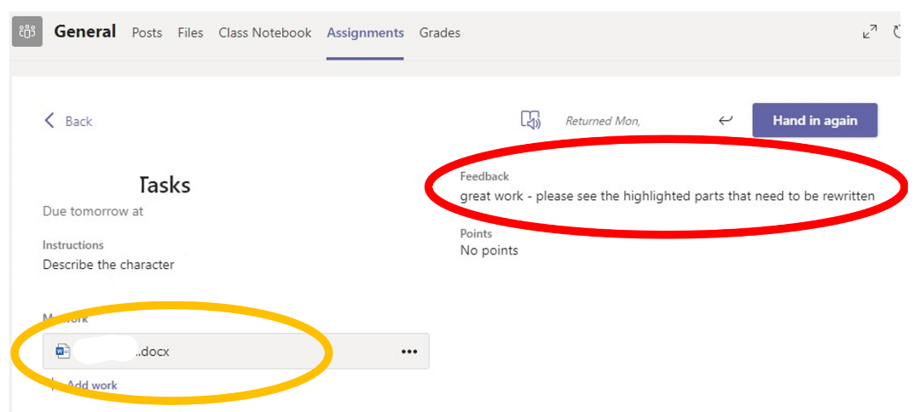
This piece of work has been looked at by this student’s teacher and been given some feedback circled in red.

You can click on the file to open it and act on the feedback given to you by your teacher, before handing it in again.
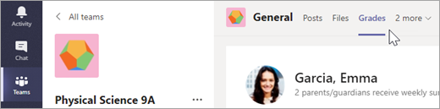
OR
Each of your class teams has a Grades tab where you can view all your assignments and grades at a glance.
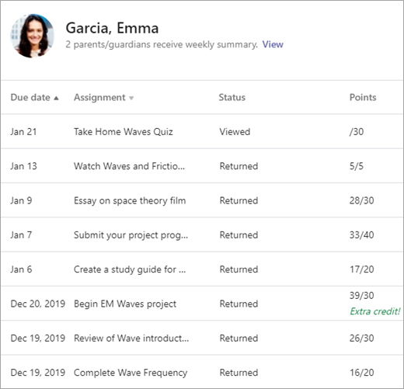
To open your Grades tab, navigate to the General channel in a class team and select Grades.
Here, you'll see all your assignments listed with the nearest due date at the top. View your status on each assignment as well as points you've received on graded work. Assignments without points will show as Returned after your teacher has reviewed them.

