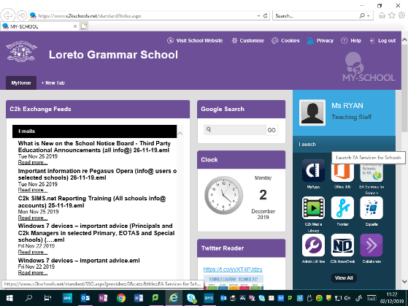
A Quick Guide for accessing Accelerated Reader

- School Computer- go to Home screen
- Click View All
- Select Custom from side tab
- Select Accelerated Reading
- Select I am a Student- Log In.
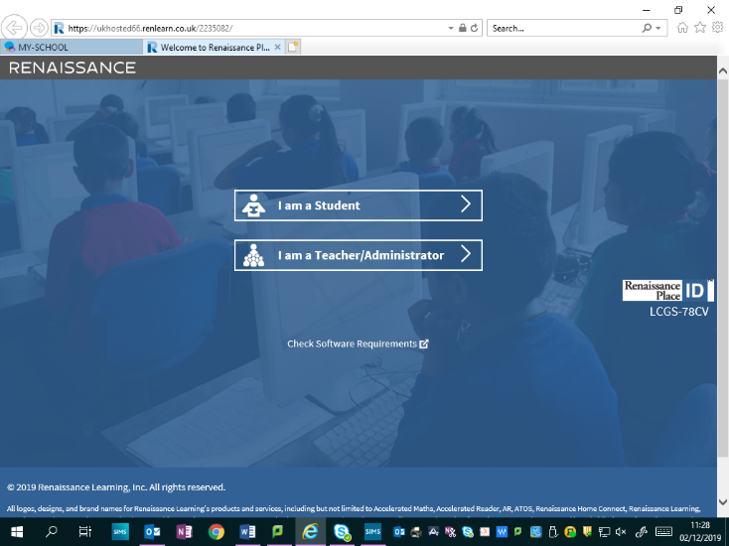
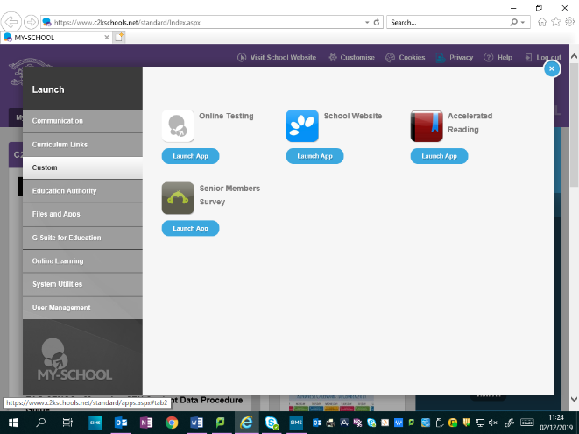

Click me

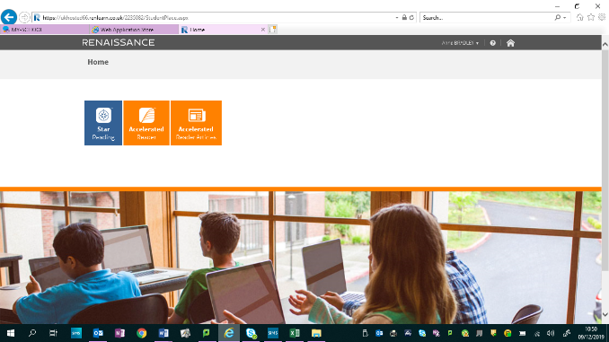
- You will have to complete the STAR test first (25 mins). This will give you your Reading Scale- the colours of books you can begin to select.

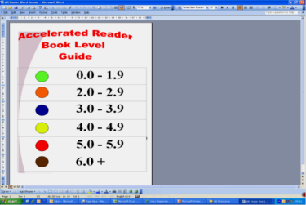
- Choose a book that interests you- check that it is in the right colour selection.

- After reading the book you should then take a quiz- Log back in to Accelerated Reader and then select Accelerated Reader.

- Search for your book. Then select Reading Practice- Take your quiz.
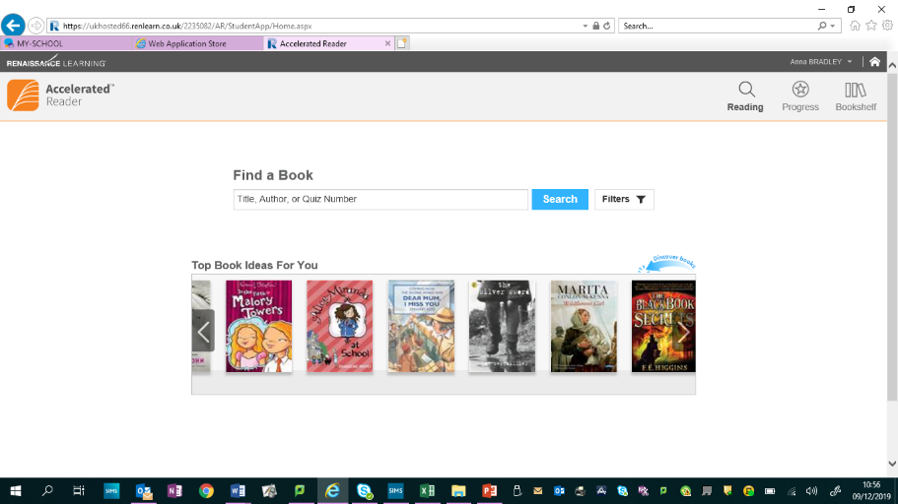

- Keep the cycle alive! You should aim to complete at least 2 quizzes in a month! There are prizes and House Points up for grabs!
Prizes and certificates are awarded for special achievements:
• WORD MILLIONAIRE AWARD
• TOP 5 READERS IN YOUR CLASS AWARD
• TOP FORM CLASS AWARD
• MOST BOOKS READ AWARD
• MOST CORRECT QUIZZES TAKEN AWARD

